Instructions for setting up a Gemini Billing Account

1. Visit this link - https://ai.google.dev/pricing
2. Click on “Set up Billing Account in Google AI Studio”.
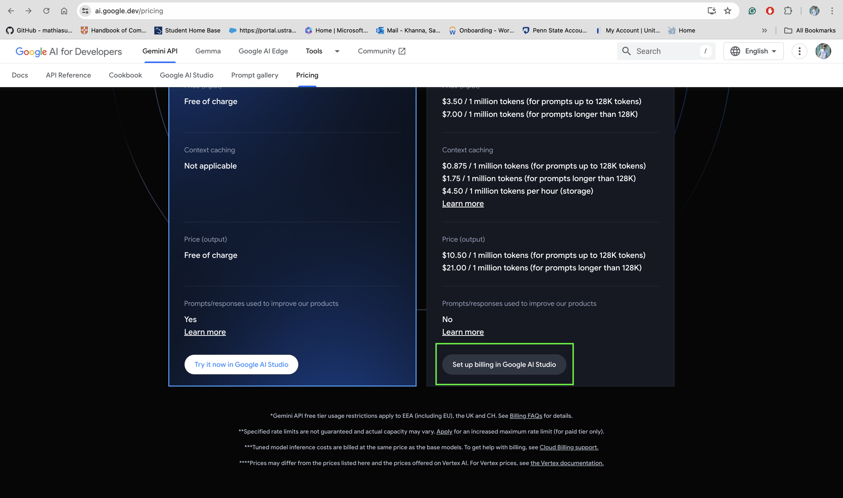

3. Click on “Set up Billing”.
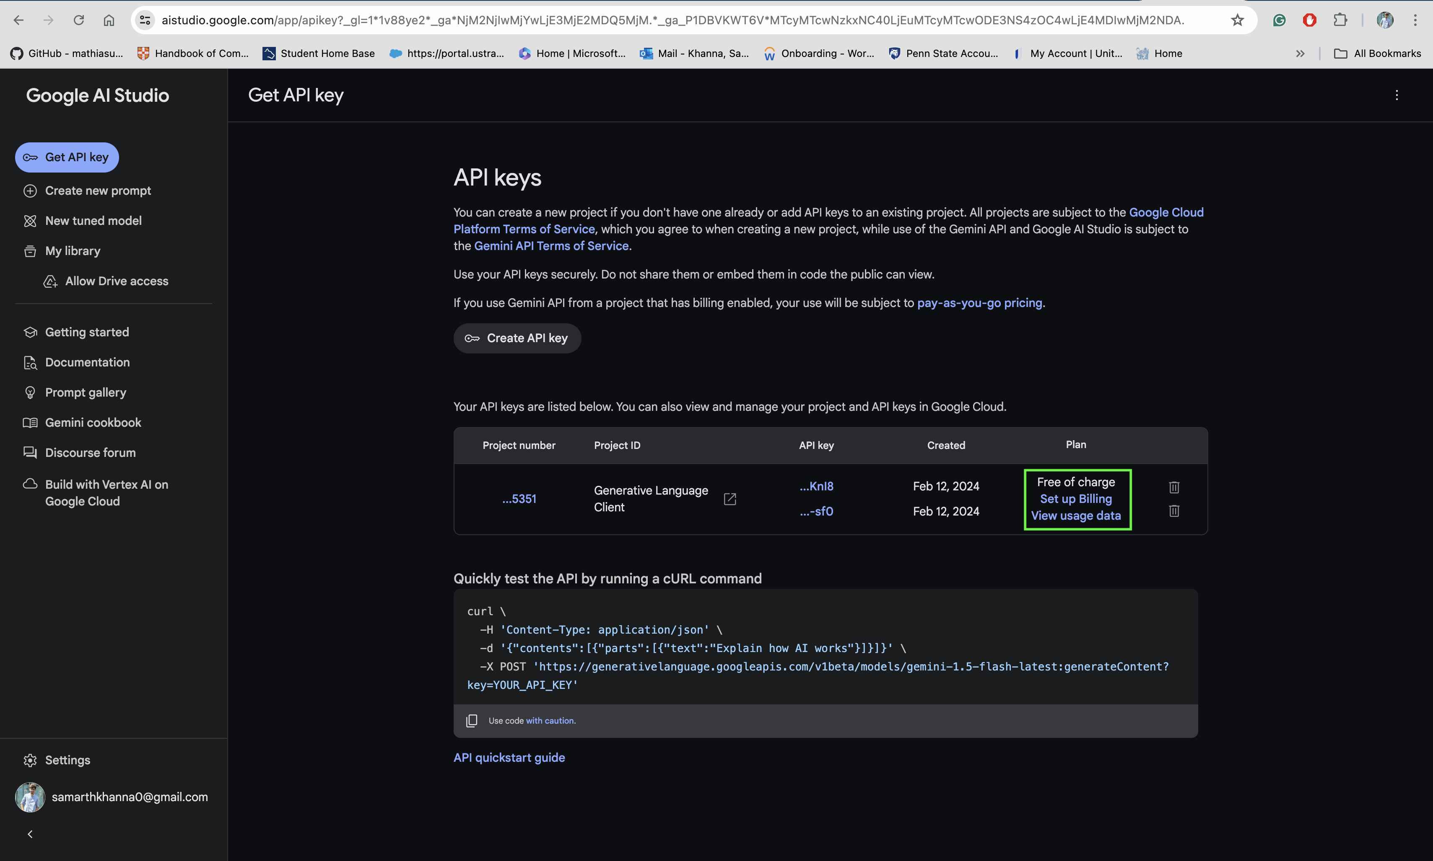

4. Click on “LINK A BILLING ACCOUNT”
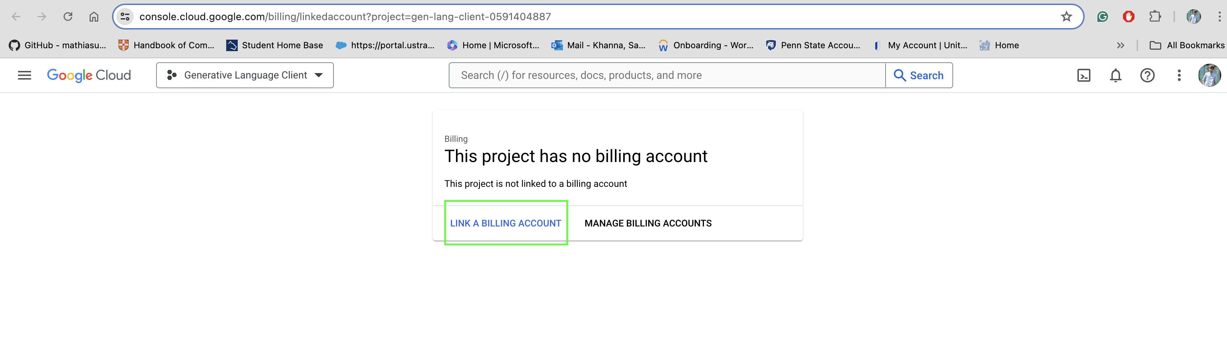

5. Click on “Manage Billing Accounts”
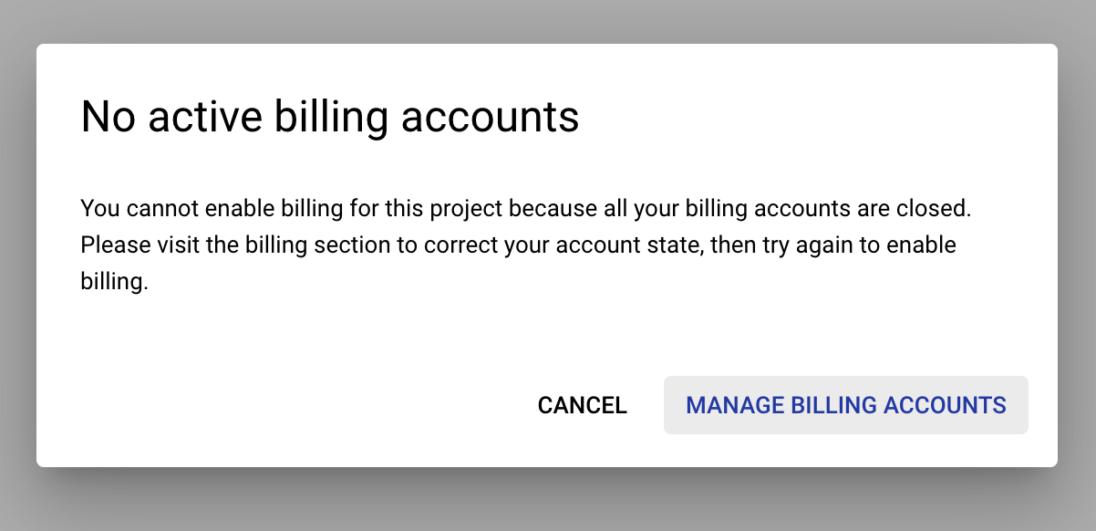

6. Click on “CREATE ACCOUNT”
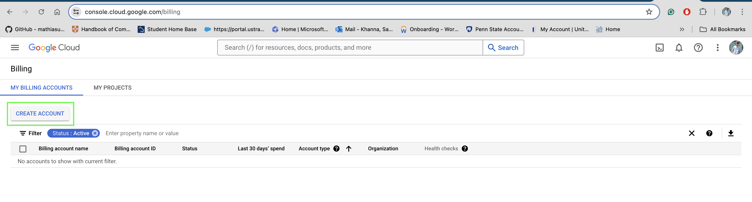

7. Click on “Continue”
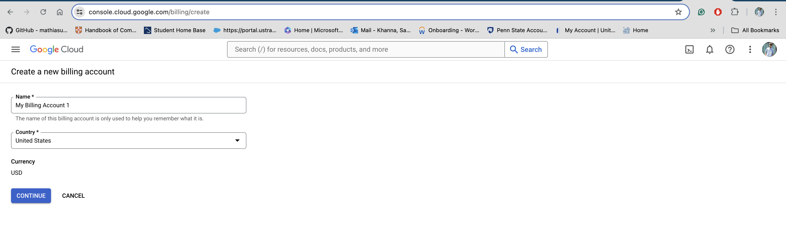
8. Provide details and click on “SUBMIT AND ENABLE BILLING”
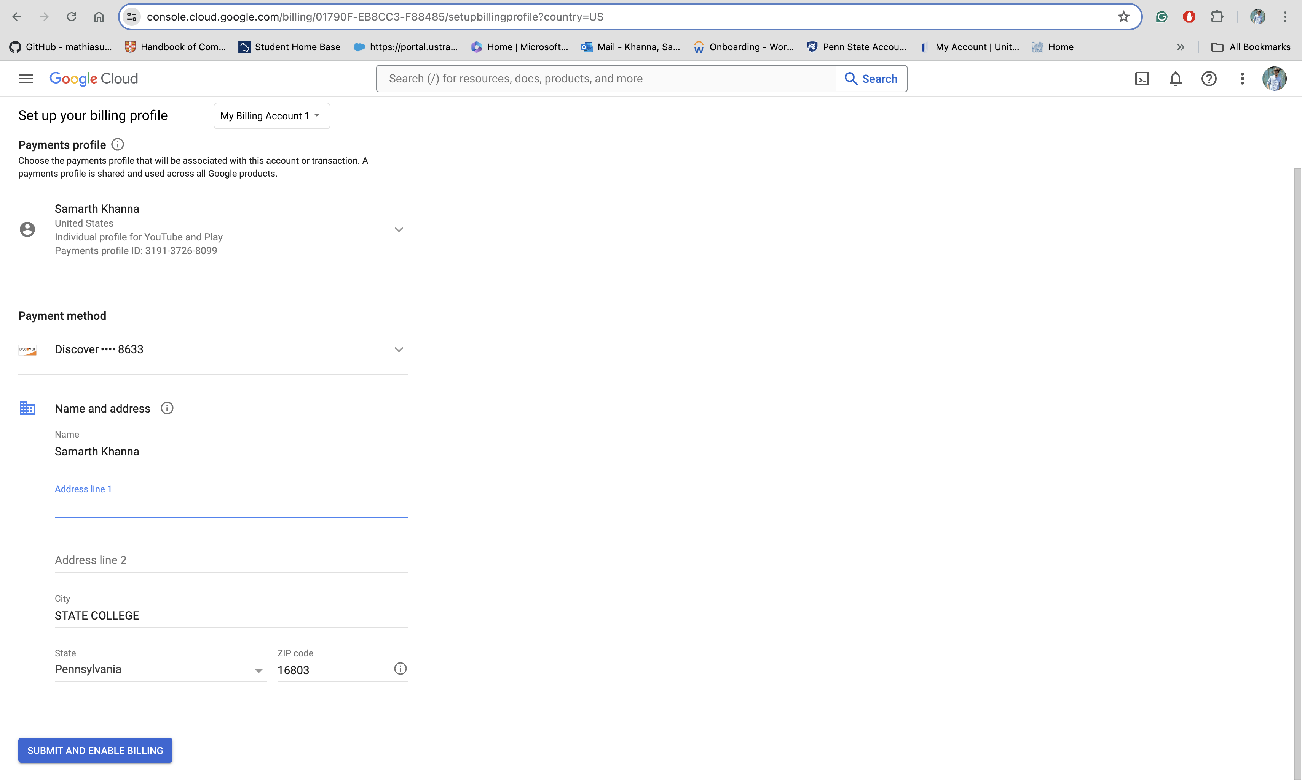

9. Set a monthly budget to get a notification when usage approaches the same, in the manner shown below.
